ASSIGNMENT-10.5
HT.NO:2303A51726

Batch-11
Task Description #1 – Variable Naming Issues Task:UseAItoimproveunclearvariablenames. Sample Input Code:
deff(a,b):
return a + b print(f(10,20))
ExpectedOutput:
- Coderewrittenwithmeaningfulfunctionandvariablenames.
CODE:
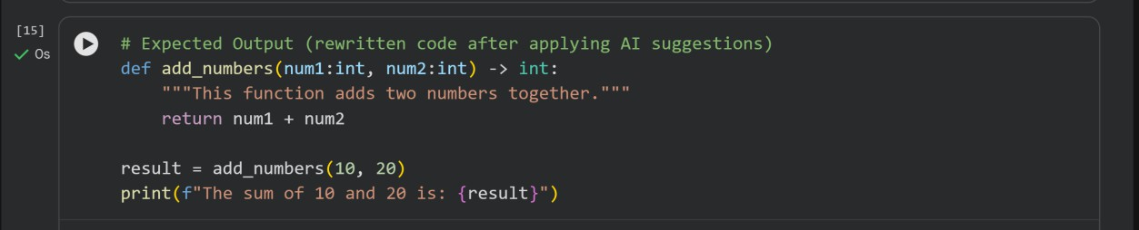
OUTPUT:

TaskDescription#2–MissingErrorHandling
Task:UseAItoaddpropererrorhandling. Sample Input Code:
defdivide(a,b):
return a / b print(divide(10,0)) Expected Output:
- Codewithexceptionhandlingandclearerrormessages
CODE:

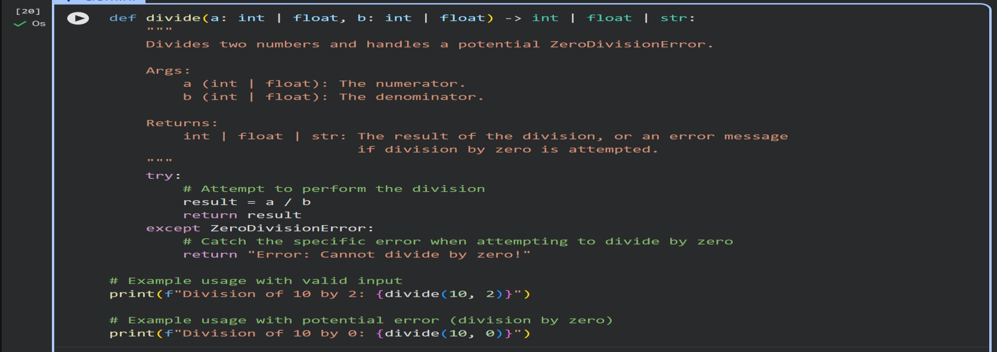
OUTPUT:

TaskDescription#3:StudentMarksProcessingSystem
Thefollowingprogramcalculatestotal,average,andgradeofa student, but it has poor readability, style issues, and no error handling.
marks=[78,85,90,66,88]
t=0
foriinmarks: t=t+i
a=t/len(marks) if a>=90: print("A")
elifa>=75: print("B") elifa>=60: print("C") else: print("F") Task:

- UseAItorefactorthecodetofollowPEP8standards.
- Addmeaningfulvariablenames,functions,andcomments.
- Addbasicinputvalidationanddocumentation.
CODE:
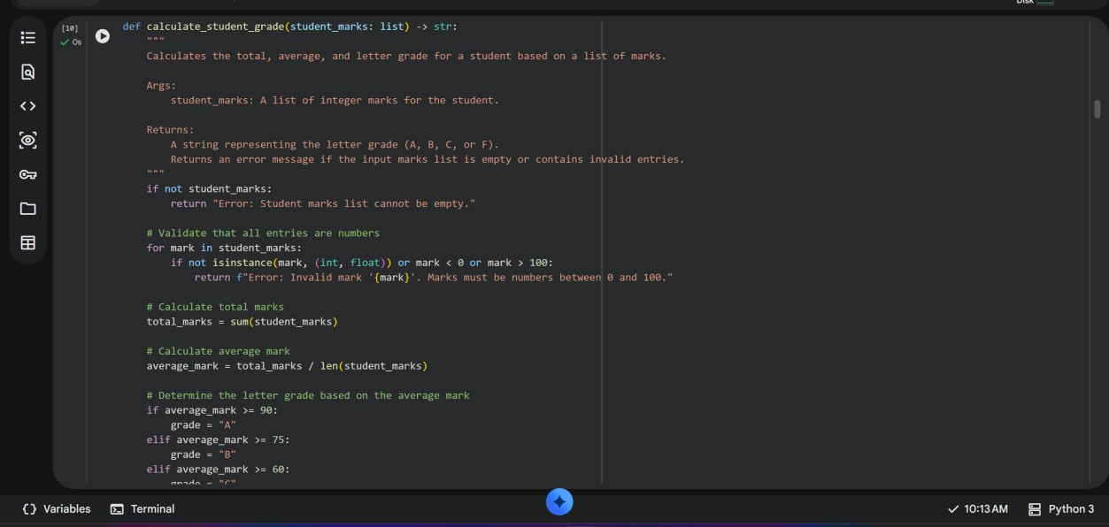
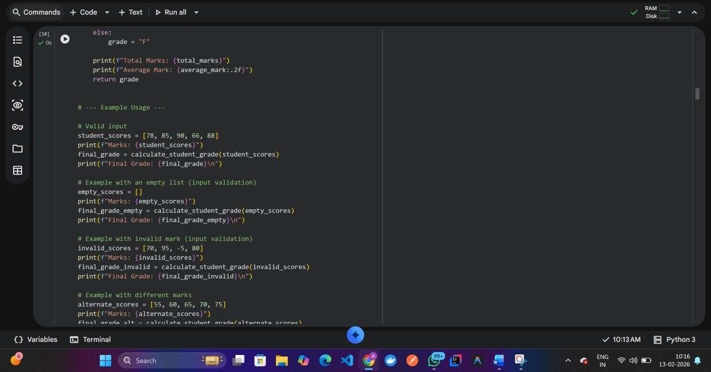

OUTPUT:
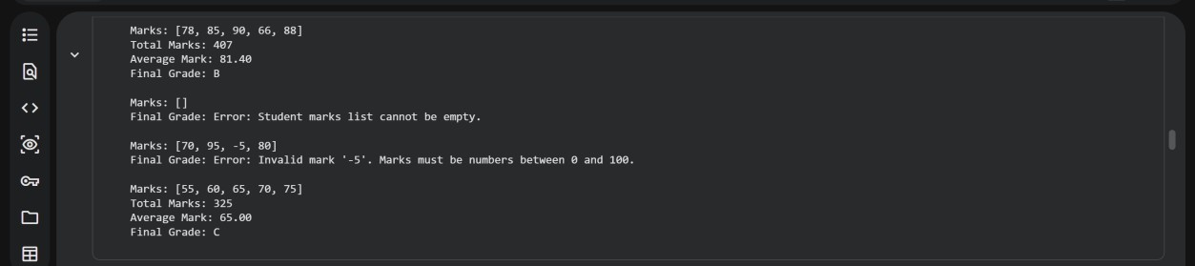
EXPLANATION:

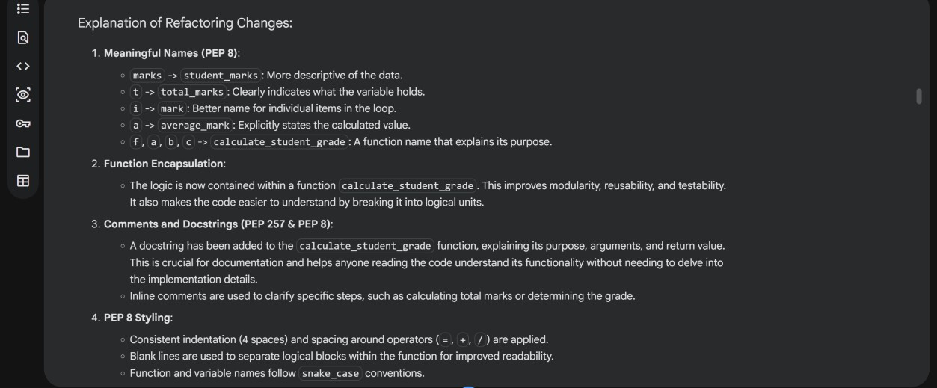
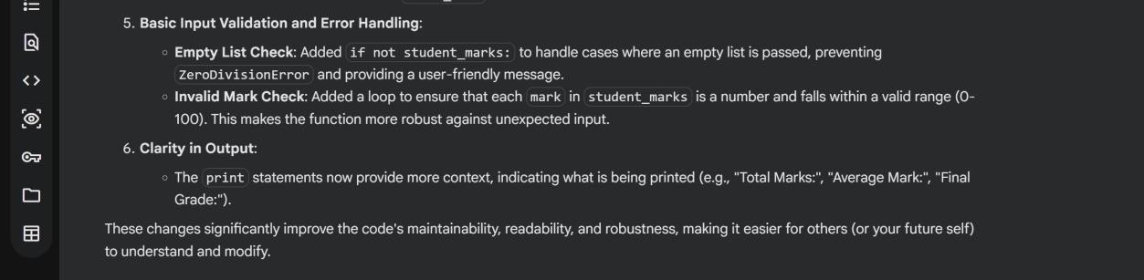

TaskDescription#4:UseAItoadddocstringsandinlinecomments
tothefollowingfunction. def factorial(n):
result=1
foriinrange(1,n+1): result *= i
returnresult
CODE:
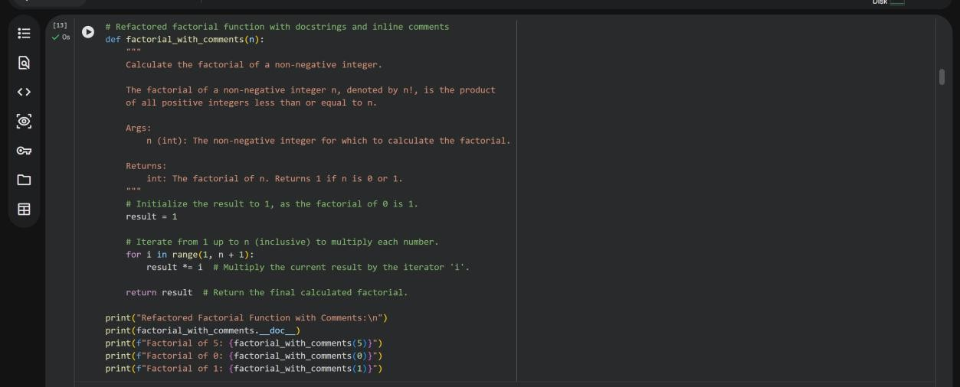

OUTPUT:
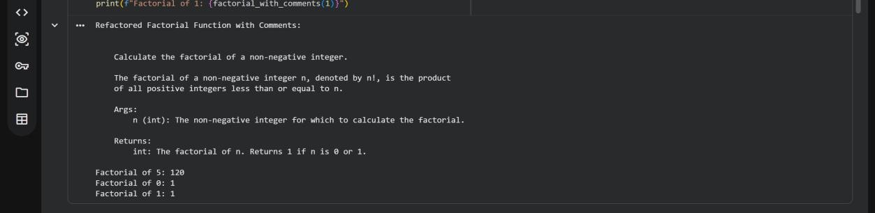

Task Description #5: Password Validation System(Enhanced)
ThefollowingPythonprogramvalidatesapasswordusingonlya minimum length check, which is insufficient for real-world
securityrequirements.
pwd=input("Enterpassword:") if len(pwd) >= 8:
print("Strong") else:
print("Weak") Task:
- EnhancepasswordvalidationusingAIassistancetoinclude multiple security rules such as:
  - Minimumlengthrequirement
  - Presenceofatleastoneuppercaseletter
  - Presenceofatleastonelowercaseletter
  - Presenceofatleastonedigit
  - Presenceofatleastonespecialcharacter
- Refactortheprogramto:
  - Usemeaningfulvariableandfunctionnames
  - FollowPEP8codingstandards
  - Includeinlinecommentsandadocstring
- AnalyzetheimprovementsbycomparingtheoriginalandAI- enhanced versions in terms of:
  - Codereadabilityandstructure
  - Maintainabilityandreusability

  - Securitystrengthandrobustness
- JustifytheAI-generatedchanges,explainingwhyeachadded rule and refactoring decision improves the overall quality of
the program.
TASKEXPLANATION:
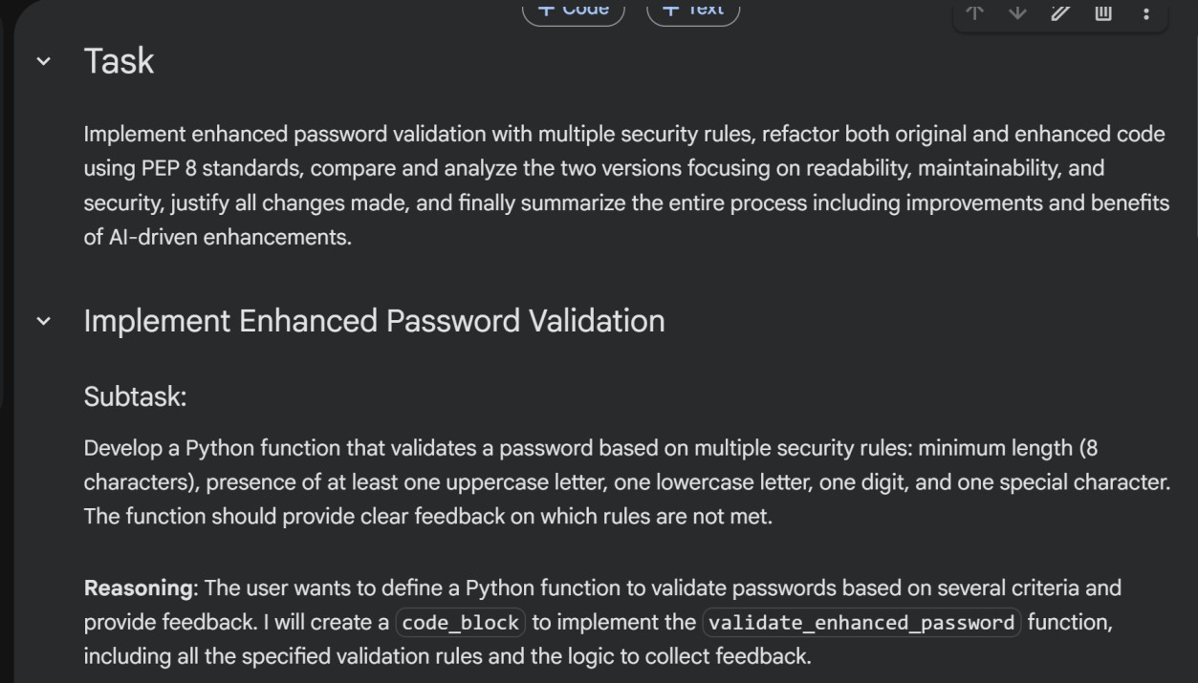
CODE:
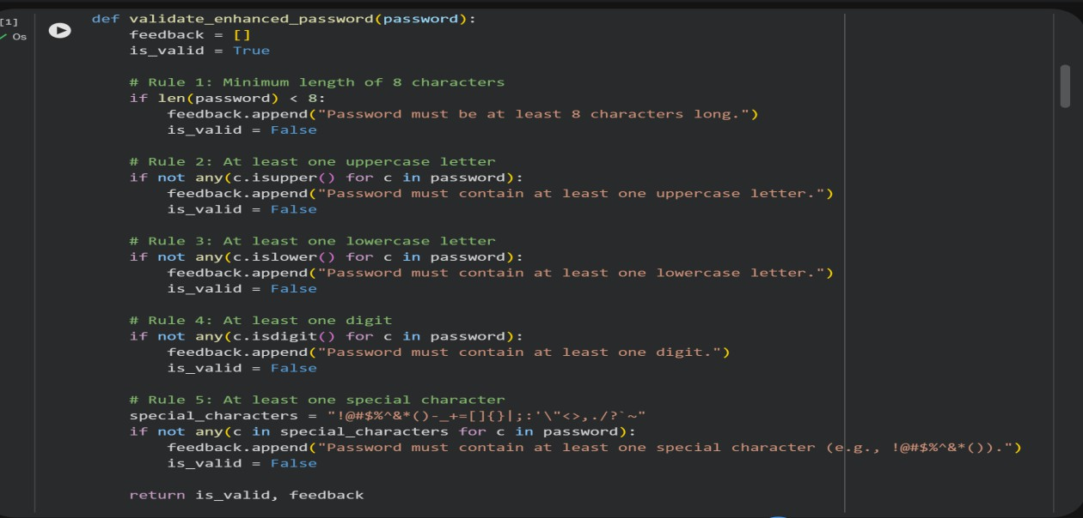

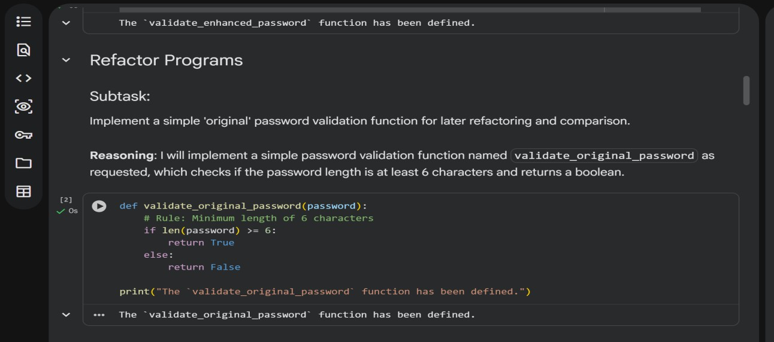
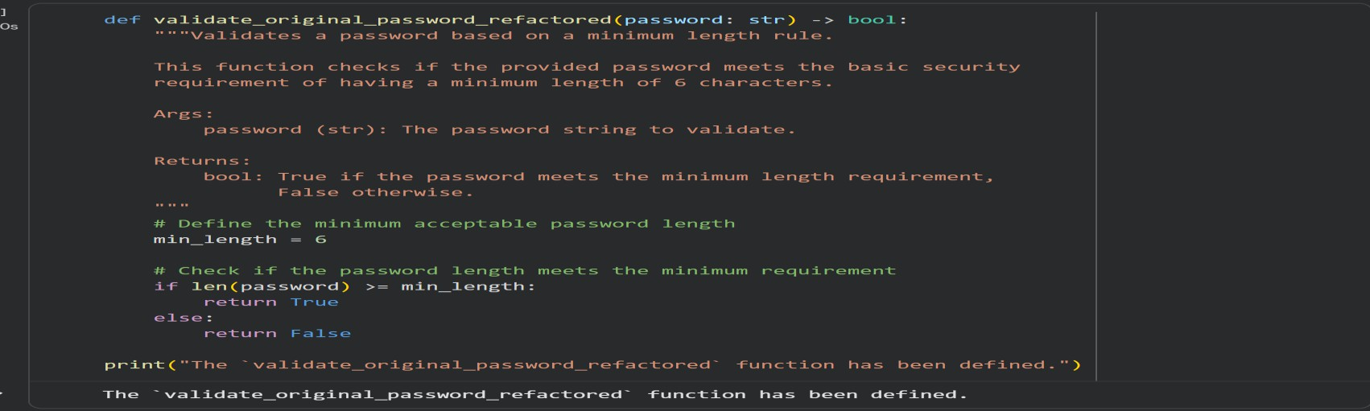
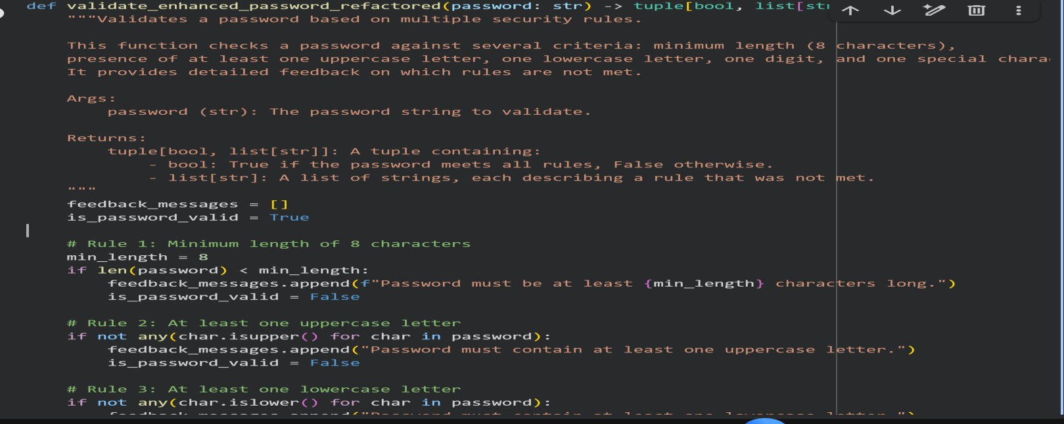

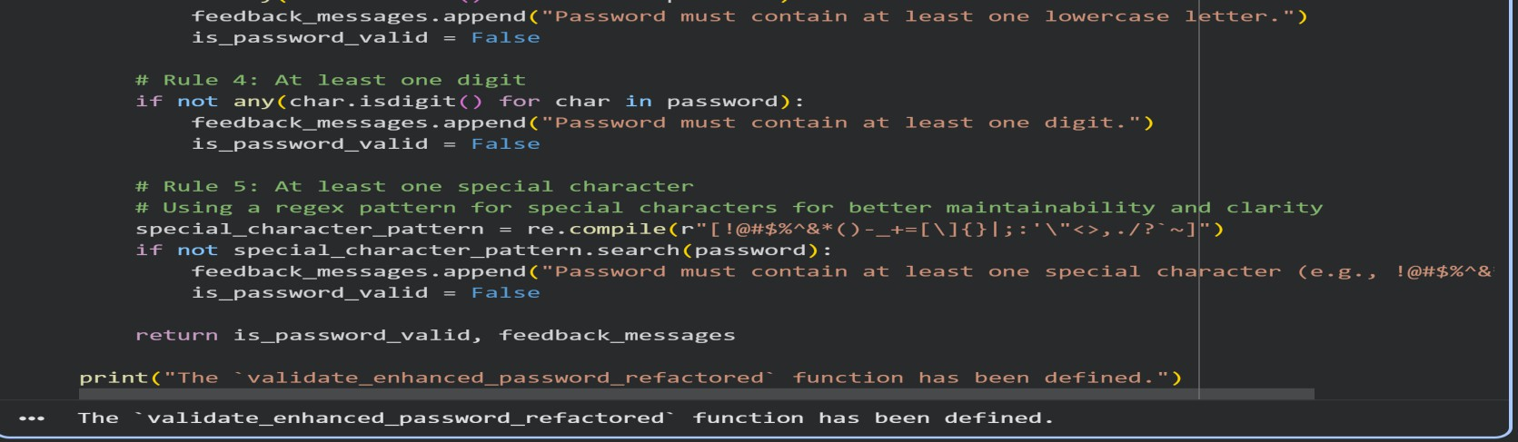
TESTCASES:
test_cases=[
{
"password":"short",
"description":"Tooshort,failsboth", "expected_original": False,
"expected_enhanced_is_valid":False,
"expected_enhanced_feedback_contains":[
"Passwordmustbeatleast8characterslong.",
"Passwordmustcontainatleastoneuppercaseletter.", "Password must contain at least one digit.",
"Passwordmustcontainatleastonespecialcharacter."
]
},
{
"password":"password123",
"description":"Meetsoriginallength,failsenhanced(nouppercase/special)", "expected_original": True,
"expected_enhanced_is_valid":False,
"expected_enhanced_feedback_contains":[
"Passwordmustcontainatleastoneuppercaseletter.", "Passwordmustcontainatleastonespecialcharacter."
]

},
{
"password":"Password!1",
"description":"Passesenhancedvalidation", "expected_original": True,
"expected_enhanced_is_valid":True,
"expected_enhanced_feedback_contains":[]
},
{
"password":"Pass123!",
"description":"Passesenhancedvalidation", "expected_original": True,
"expected_enhanced_is_valid":True,
"expected_enhanced_feedback_contains":[]
},
{
"password":"NoSpecialChar1",
"description":"Failsenhanced(nospecialchar)", "expected_original": True,
"expected_enhanced_is_valid":False,
"expected_enhanced_feedback_contains":[
"Passwordmustcontainatleastonespecialcharacter."
]
},
{
"password":"NOUPPERCASE!1",
"description":"Failsenhanced(nolowercase)", "expected_original": True,
"expected_enhanced_is_valid":False,
"expected_enhanced_feedback_contains":[
"Passwordmustcontainatleastonelowercaseletter."

]
},
{
"password":"nouppercase!_",
"description":"Failsenhanced(nouppercase/digit)", "expected_original": True,
"expected_enhanced_is_valid":False,
"expected_enhanced_feedback_contains":[
"Passwordmustcontainatleastoneuppercaseletter.", "Password must contain at least one digit."
]
},
{
"password":"NOLOWERCASENODIGIT!",
"description":"Failsenhanced(nolowercase/digit)", "expected_original": True,
"expected_enhanced_is_valid":False,
"expected_enhanced_feedback_contains":[
"Passwordmustcontainatleastonelowercaseletter.", "Password must contain at least one digit."
]
}
]
print(f"Defined{len(test_cases)}passwordtestcases.")

OUTPUT:
